Course Code: CXT332
Course Name: MULTIMEDIA TECHNOLOGIES
Max. Marks: 100 |  |  |  | Duration: 3 Hours
PART A
 |  | Answer all questions, each carries 3 marks. |  |  | Marks
1 |  | Multimedia:  Multimedia refers to the integration of multiple types of media to convey information, including text, audio, graphics, images, video, and animation.It allows computer systems to present and process data through a variety of media formats.Multimedia focuses on delivering information using both traditional text and graphic elements combined with richer forms like audio and video.- – 1.5 marks  Hypermedia:While hypertext allows non-linear navigation of text documents, hypermedia includes other media types such as graphics, images, audio, and video.Hypermedia is not limited to text-based content; it incorporates various media to create interconnected, non-linear navigation systems.The World Wide Web (WWW) is a prime example of a hypermedia application. – 1.5 marks |  |  | (3)
2 |  | Tweening (short for in-betweening) is an essential technique in animation and computer graphics used to generate intermediate frames between two keyframes to create smooth motion. There are different types of tweening, categorized based on how the interpolation is applied.  Types of Tweening:  1. Linear Tweening  - The simplest form of tweening where motion progresses at a constant speed.There is no acceleration or deceleration.Often results in unnatural motion since real-world objects usually do not move at a constant speed.  2. Ease-In (Acceleration)  - The animation starts slowly and then gradually speeds up toward the next keyframe.Mimics natural acceleration, such as a car starting to move.Useful for creating realistic motion.  3. Ease-Out (Deceleration)  - The animation starts fast and then slows down as it approaches the next keyframe.Commonly used for objects coming to a stop, such as a ball rolling to a halt.  4. Ease-In-Out (Acceleration and Deceleration)  - The animation starts slowly, speeds up in the middle, and then slows down towards the end.Creates a smooth and natural movement, often used in UI animations.  5. Path Tweening (Motion Tweening)  - Moves an object along a predefined path rather than in a straight line.  - Useful for animating curved or complex trajectories, such as a bird flying.  6. Shape Tweening (Morphing)  - Changes one shape into another over time by interpolating their points.  - Used in vector-based animation software like Adobe Animate. |  |  | (3)
3 |  | Music is organized into tracks in a sequencer. Each track can be turned on or off on recording or playing back. Usually, a particular instrument is associated with a MIDI channel. MIDI channels are used to separate messages. There are 16 channels, numbered from 0 to 15.  Write important aspects of midi . |  |  | (3)
4 |  | Entropy Coding Models:  - Huffman Coding – Assigns variable-length codes to symbols based on their frequencies.  - Arithmetic Coding – Represents entire messages as a single fractional number, achieving better compression than Huffman coding. |  |  | (3)
5 |  | - Rate (R): The number of bits per symbol required to encode the source.  - Distortion (D): The error or loss incurred when reconstructing the signal after compression.  Rate-Distortion Function (R(D)): The minimum bit rate required to achieve a given level of distortion.For a given source and a given distortion measure, if D is a tolerable amount of distortion, R(D) specifies the lowest rate at which the source data can be encoded while keeping the distortion bounded above by D.  Explanation - 3 marks |  |  | (3)
6 |  | - A Channel Vocoder is a type of vocoder, a signal processing technique used for speech synthesis and analysis, where it primarily operates by analyzing and modifying the spectral characteristics of a speech signal. The channel vocoder works by splitting the input signal (usually speech) into several frequency bands, then processing and encoding those bands separately. It is one of the oldest and simplest forms of vocoding, and it has been widely used in various applications such as telecommunications, music production, and speech synthesis.  - A Formant Vocoder is a type of vocoder that uses formant analysis to synthesize and manipulate speech or vocal sounds. Vocoders, in general, are signal processing tools used to combine and modify an audio signal (usually a voice) with a carrier signal, often to create robotic or otherworldly effects. |  |  | (3)
7 |  | Content-Based Image Retrieval (CBIR) is a technique used to search and retrieve images from a database based on their visual content rather than textual metadata. Instead of relying on keywords, CBIR analyzes features such as color, texture, shape, and spatial relationships to find similar images. |  |  | (3)
8 |  | 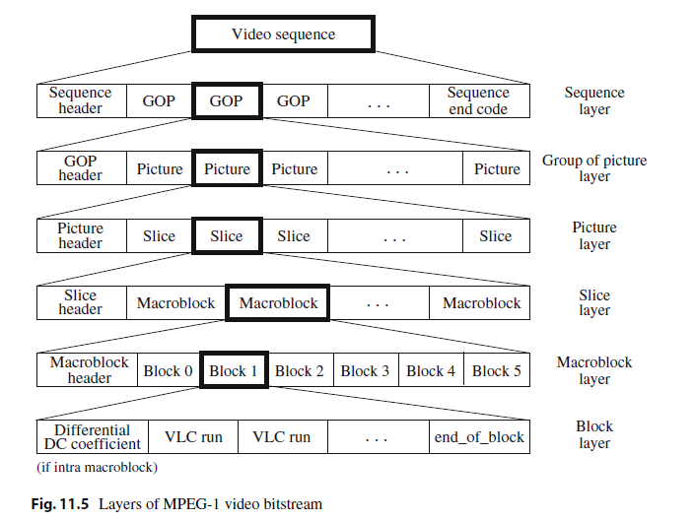  Diagram -3 mark |  |  | (3)
9 |  | A public cloud is a cloud computing model where computing resources, such as servers, storage, and applications, are provided over the internet by third-party cloud providers like AWS, Microsoft Azure, and Google Cloud. – 1.5 marks  A private cloud, on the other hand, is a cloud infrastructure dedicated to a single organization, either hosted on-premises or managed by a third-party provider. It offers greater security, control, and customization, making it suitable for businesses with strict regulatory requirements or sensitive data– 1.5 marks |  |  | (3)
10 |  | 1. Scalability & Global Reach  - Cloud platforms use Content Delivery Networks (CDNs) to distribute streams across multiple geographic locations.  2. Low Latency Streaming  - Edge computing in cloud networks ensures low-latency video delivery by processing data closer to users.  3. Multi-Platform & Device Compatibility  - Cloud-based encoding allows live streams to be automatically transcoded into multiple formats.  - Ensures compatibility across smartphones, tablets, smart TVs, and desktops. |  |  | (3)
PART B
Answer one question from each module, each carries 14 marks.
 |  | Module I
11 | a) | - The categories of software tools:-  - Music sequencing and notation  - Digital audio  - Graphics and image editing  - Video editing  - Animation  - Multimedia authoring.  Explain each category of tool
 | b) | - RGB COLOR MODEL  - The RGB color model is one of the most widely used color representation method in computer graphics.  - It use a color coordinate system with three primary colors:  R(red), G(green), B(blue)  - Each primary color can take an intensity value ranging from 0(lowest) to 1(highest).  - Mixing these three primary colors at different intensity levels produces a variety of colors. The collection of all the colors obtained by such a linear combination of red, green and blue forms the cube shaped RGB color space.  - Additive Color model.  - Each primary color can take an intensity value ranging from 0(lowest) to 1(highest). 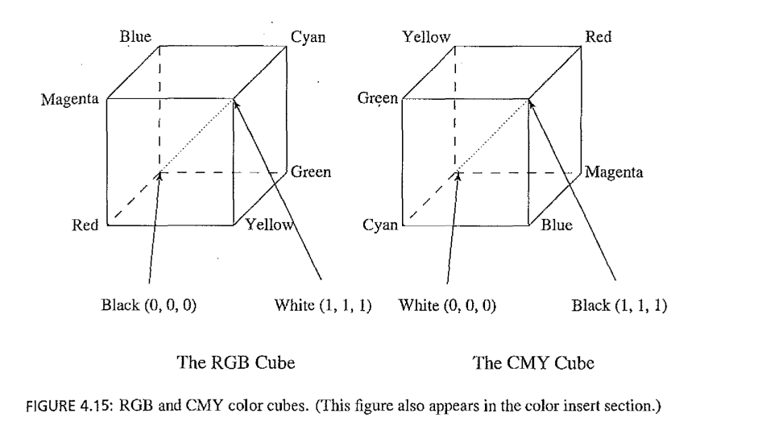  - CMY color model  The CMY color model is a subtractive color model used in color printing and photography. It is based on the three primary colors of pigment:  - Cyan (C),Magenta (M),Yellow (Y)  - Unlike the RGB model, which is additive (colors are created by adding light), the CMY model is subtractive—it works by absorbing certain wavelengths of light and reflecting others.  - Cyan absorbs red and reflects green and blue.  - Magenta absorbs green and reflects red and blue.  - Yellow absorbs blue and reflects red and green.  - When all three CMY colors are combined at full intensity, they ideally produce black (absorbing all light).  - Undercolor Removal :CMYK System  The CMYK color model is an extension of the CMY (Cyan, Magenta, Yellow) color model, used mainly in printing. The "K" in CMYK stands for Black (Key) because black ink is used in addition to CMY to produce darker tones and sharper prints.  - 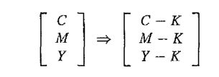  Explanation, diagram and equations if any
 |  | OR
12 | a) | 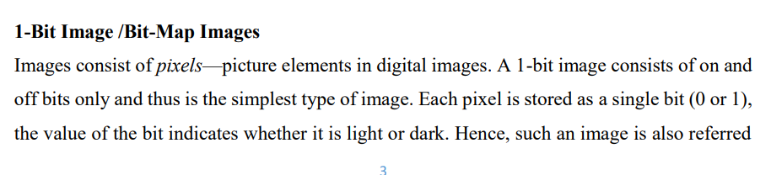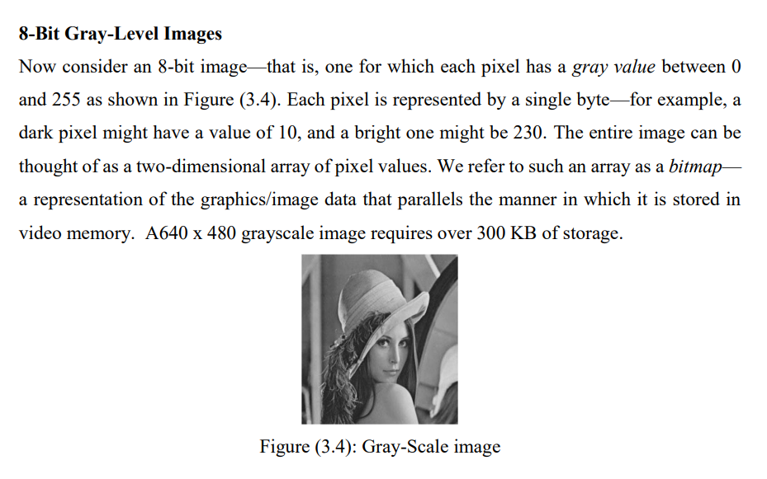  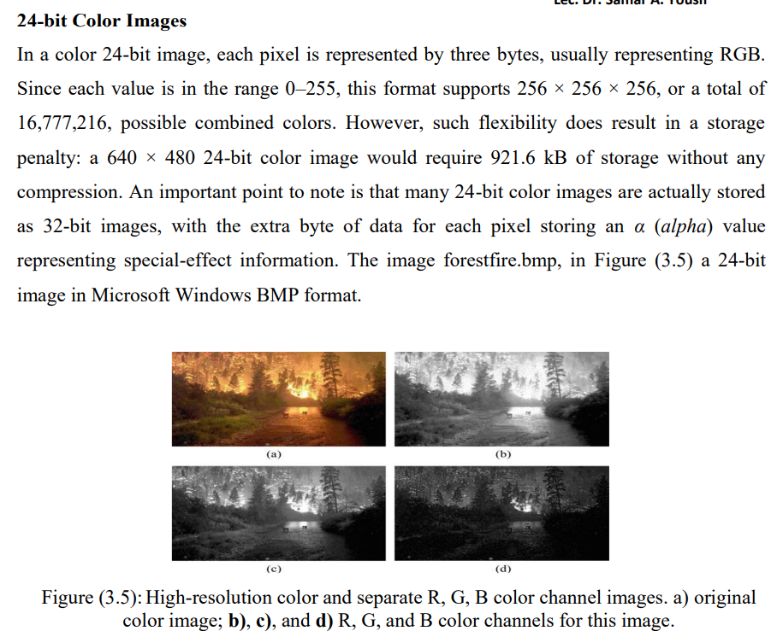  8-bit color images  An 8-bit color image is an image where each pixel is represented using 8 bits (1 byte). This allows for 256 different colors in the image.  Instead of using full 24-bit RGB color (where each pixel has 8 bits for red, green, and blue), 8-bit images use a color palette with 256 predefined colors.  Each pixel does not store the full RGB value; instead, it stores an index number (0-255) that points to a specific color in the palette. (3 marks for each model=3x4=12 marks)  Color Lookup Table  - CLUT is a method used to transform a range of input colors into another range of colors.  - CLUT is a function incorporated in an image processing application. (2 marks)
 |  | Module II
13 | a) | Huffman Coding  Huffman coding is a popular algorithm used in data compression. It helps reduce the size of data by encoding information using variable-length codes, where frequently occurring symbols (characters or data items) are assigned shorter codes, and less frequent symbols are assigned longer codes  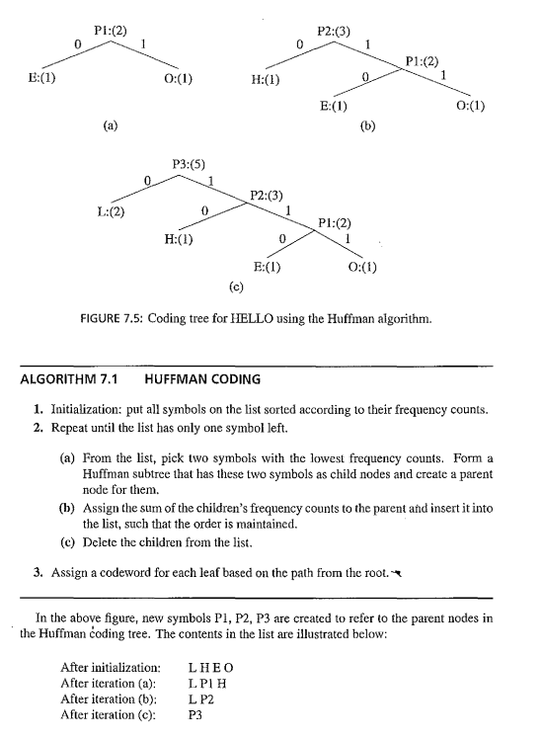  B)
 | b) | - 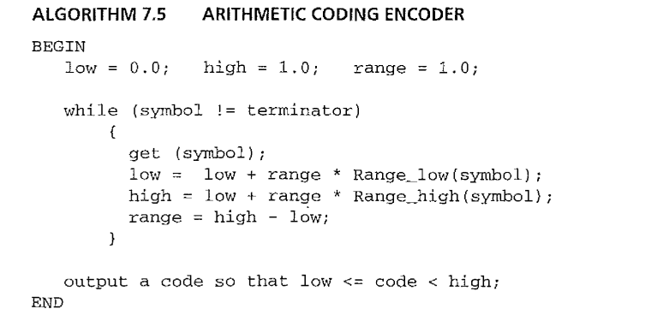  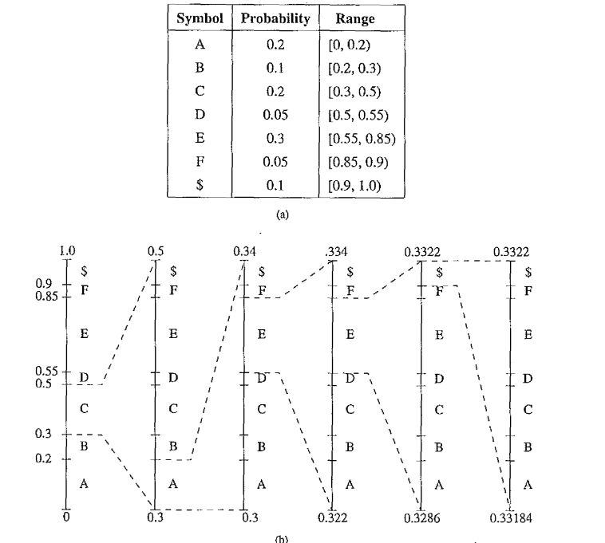
 |  | OR
14 | a) | 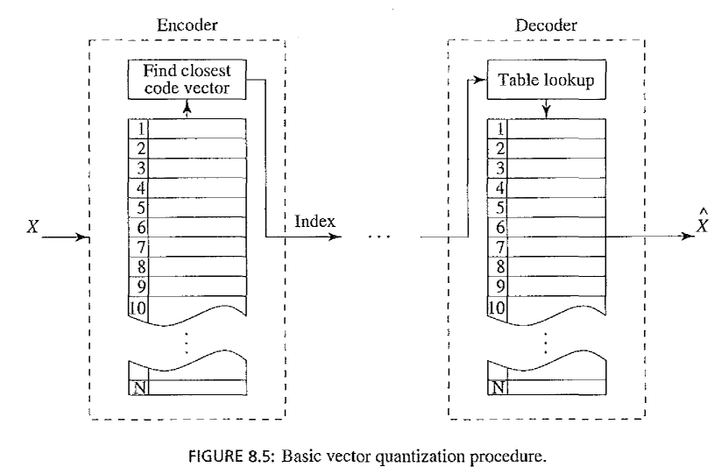  Merits of Vector Quantization Over Scalar Quantization  - Better Compression Efficiency:  - VQ compresses multiple values together rather than individual values, leading to lower bit rates.  - Higher Signal Quality:  - Since VQ considers the correlation between different components of a vector, it reduces quantization noise compared to scalar quantization.  - Improved Rate-Distortion Performance:  - VQ offers a better trade-off between bit rate and distortion, making it ideal for image and audio compression (e.g., JPEG, MP3).  - Effective for High-Dimensional Data:  - Unlike scalar quantization, which processes data one element at a time, VQ efficiently handles multi-dimensional signals, preserving spatial relationships in images.
 | b) | Digitization of Sound  Digitization is the process of converting an analog audio signal into a digital format that can be stored and processed by computers. This process involves sampling, quantization, and encoding.  Steps in Digitization:  - Sampling: The analog signal is measured at regular intervals to create discrete data points.  - Quantization: The sampled values are approximated to the nearest discrete level.  - Encoding: The quantized values are represented as binary numbers for storage and processing.  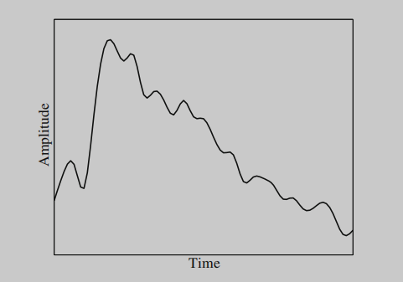 fig 6.1  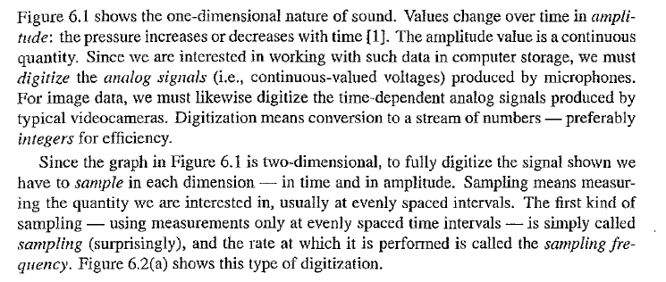
 |  | Module III
15 | a) | 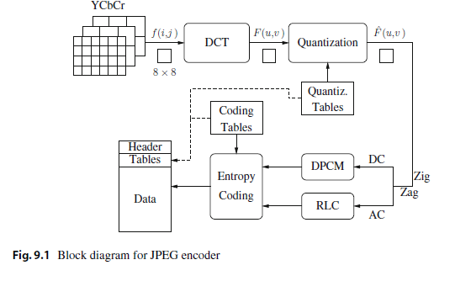  Main Steps in JPEG Image Compression  • Transform RGB to YCbCr and subsample color  • Perform DCT on image blocks  • Apply Quantization  • Perform Zigzag ordering and run-length encoding  • Perform Entropy coding |  |  | )
 | b) | Difference Between JPEG and JBIG Standards  - Purpose:  - JPEG (Joint Photographic Experts Group) is designed for compressing continuous-tone images such as photographs, both grayscale and color.  - JBIG (Joint Bi-level Image Experts Group) is specialized for compressing bi-level (black-and-white) images, commonly used in scanned documents and fax transmissions.  - Compression Type:  - JPEG supports both lossy and lossless compression, but it is primarily used for lossy compression.  - JBIG primarily uses lossless compression, ensuring no data loss, which is critical for document imaging.  - Compression Algorithm:  - JPEG relies on Discrete Cosine Transform (DCT) for lossy compression and Huffman or Arithmetic coding for lossless compression.  - JBIG uses Arithmetic coding combined with Markov-based prediction, which provides better compression efficiency for binary images.  - File Format and Extensions:  - JPEG files are commonly stored as .jpg, .jpeg, or .jfif.  - JBIG files are stored as .jbg or .jbig.  - Efficiency:  - JPEG is more efficient for natural images with smooth color transitions, such as digital photos.  - JBIG is highly efficient for scanned text documents and line art, often outperforming other document compression methods like TIFF Group 4.  - Color Support:  - JPEG supports full-color (RGB, CMYK, and grayscale) images.  - JBIG is primarily designed for monochrome (black-and-white) images, though JBIG2 extends support to grayscale and color.
 |  | OR
16 | a) | Modes of JBIG Compression  According to the provided image, JBIG has three modes of operation:Explain modes  The JBIG2 Standard  • The design goal for JBIG2 aims not only at providing superior lossless compression performance over existing standards but also at incorporating lossy compression at a much higher compression ratio, with as little visible degradation as possible.  • A unique feature of JBIG2 is that it is both quality progressive and content progressive.  The JBIG2 encoder decomposes the input bi-level image into regions of different attributes and codes each separately, using different coding methods  Explain
 | b) | - Uniform Scalar Quantization  - A uniform scalar quantizer partitions the domain of input values into equally spaced intervals, except possibly at the two outer intervals. The endpoints of partition intervals are called the quantizer’s decision boundaries. The output or reconstruction value corresponding to each interval is taken to be the midpoint of the interval. The length of each interval is referred to as the step size, denoted by the symbol θ.  - Definition – 1 marks  - Midrise and Midtread -equations and explanation – 4 marks  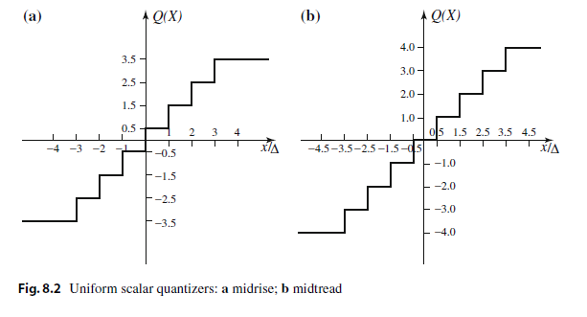  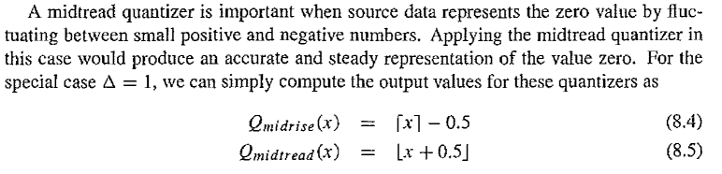  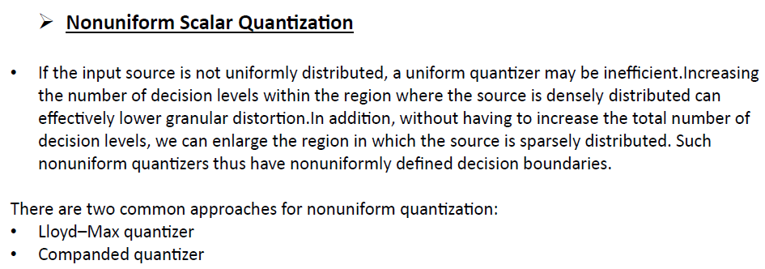
 |  | Module IV
17 | a) | Similarity-Based Retrieval (SBR) – Explanation and Example  Similarity-Based Retrieval (SBR) is a technique used in information retrieval where items similar to a given query are retrieved based on a similarity measure. It is widely used in search engines, image recognition, recommendation systems, and pattern matching.  How Similarity-Based Retrieval Works  - Feature Extraction:  - The system extracts key features from both the query and stored data.  - Features could be text, image properties, audio patterns, or numerical values.  - Similarity Measurement:  - A similarity metric (e.g., Euclidean distance, Cosine similarity, Jaccard index) is used to compare the query with the stored data.  - Ranking and Retrieval:  - Items are ranked based on similarity scores.  - The most similar items are retrieved and presented to the user.  Example of Similarity-Based Retrieval  Example 1: Image Search in Google  - Suppose a user uploads a picture of a red sports car to Google Images.  - Google analyzes the image’s color, shape, and patterns and retrieves similar images of red sports cars, even if they are from different angles or backgrounds.  Example 2: Music Recommendation (Spotify, YouTube Music)  - If a user listens to soft instrumental music, the system extracts features like tempo, genre, and mood.  - It retrieves and recommends similar instrumental tracks based on previous listening history.
 | b) | 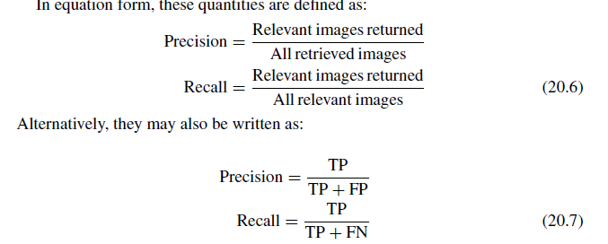  CBIR Definition– 1 mark  Precision and recall definition – 2marks  Equations and explanations -2 marks
 |  | OR
18 | a) | MPEG-2  interlaced video each frame consists of two fields, referred to as the top-field and the bottom-field. In a frame-picture, all scanlines from both fields are interleaved to form a single frame. This is then divided into 16 × 16 macroblocks and coded using motion compensation. On the other hand, if each field is treated as a separate picture, then it is called field picture.  Definition of interlaced video –  Diagram-  Other explanation of MPEG 2-  Five Modes of Predictions -  MPEG-2 defines frame prediction and field prediction as well as five different prediction modes.  MPEG -4  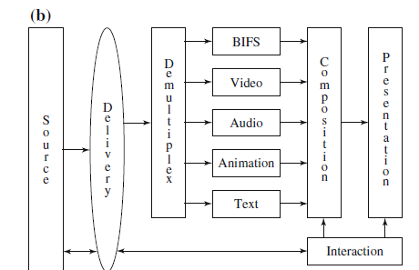  • Video Objects (VOs) – Each scene is divided into separate objects, such as a moving person, background, or a specific animated element.  • Video Object Planes (VOPs) – These are time-based snapshots of objects, similar to frames in traditional video.  • Object-Based Compression – Instead of compressing the whole frame, MPEG-4 encodes each object separately, improving compression efficiency and enabling better manipulation.  Diagram  Definition and layers -
 | b) | Content-Based Image Retrieval (CBIR) is a technique used to search and retrieve images from a database based on their visual content rather than textual metadata. Instead of relying on keywords, CBIR analyzes features such as color, texture, shape, and spatial relationships to find similar images.  Definition and explanation –
 |  | Module V
19 | a) | Infrastructure as a service  (IaaS), Platform as a service (PaaS), and Software as a service (SaaS),  - IaaS is the very basic and essential cloud service. Well-known examples of IaaS include such infrastructure vendor environments as the Amazon’s Elastic Compute Cloud (EC2), which allow users to rent virtual machines on which to run applications, and such cloud storage services as Amazon’s Simple Storage Service (S3), which allow users to store and retrieve data, at any time, from anywhere on the Web..  - PaaS delivers development environments as a service, which typically includes the operating system, programming language execution environment, database, web server, etc. .  - SaaS, probably the most widely used cloud service model to date, allows an application to run on the infrastructure and platforms offered by the cloud rather thann on local hardware/software. -  - Diagram –  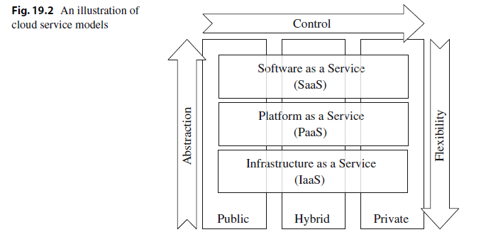
- Assembling local resources and remote clouds organically to make offloading transparent to end users requires nontrivial effort.
- First, motivation for offloading. In the very beginning, the major motivation to offload should be determined, to save energy locally, to improve computation performance, or both. This will serve as a guideline in the high-level design.
- Second, gain of offloading. To understand the potential gain after offloading, a profiling or breakdown analysis of the application is needed to see whether the application can benefit from offloading. There is no incentive to resort to the cloud for a job that can be easily and efficiently executed locally.
 |  | OR
20 | a) | - Multimedia Cloud Computing:  - Multimedia applications (e.g., video conferencing, image search, gaming) require high storage and computing power.Using cloud computing allows multimedia data to be stored and processed without installing heavy software on local devices.Quality of Service (QoS) in Multimedia Cloud Computing.QoS is essential for smooth multimedia delivery (e.g., low buffering for video streaming).  - Media Cloud is the backend infrastructure that powers Cloud Media.It includes storage, CPU, GPU, load balancers, and resource allocation to ensure smooth multimedia processing and delivery.  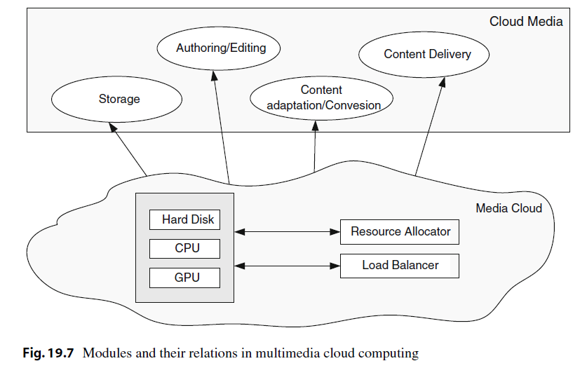
 | b) | Latency and Lag Issues Problem: Cloud gaming requires real-time interactions, and even small delays (latency) can negatively affect gameplay.  High Bandwidth Requirements Problem: Cloud gaming requires a stable, high-speed internet connection for smooth streaming.  Data Centers and Infrastructure Costs Problem: Running cloud gaming services requires powerful data centers, which are expensive to maintain.  Game Library Limitations Problem: Not all games are optimized for cloud gaming.
****

End Semester Examination Pattern: There will be two parts; Part A and Part B. Part A contain 10 questions with 2 questions from each module, having 3 marks for each question. Students should answer all questions. Part B contains 2 questions from each module of which student should answer any one. Each question can have maximum 2 sub-divisions and carry 14 marks.

